**ADDENDUM TO** **NORTHERN REGION PLANNING PANEL**

COUNCIL ASSESSMENT REPORT

Panel Reference: PPSNTH-73

DA Number: 0583/21DA

Proposed Development: Mixed Use Development Comprising Demolition of Existing Buildings, Construction of Retail Premises (7 Shops) and Shop Top Housing (95 Residential Apartments)

Prepared by: Clayton Logan, Development Assessment Officer

Report date: 16/06/2021

This addendum provides supplementary detail in relation to Clause 7.1 and 7.3 of the Coffs Harbour Local Environmental Plan 2013 (CHLEP 2013.

This addendum also provides two (2) revised conditions to that originally provided to the Panel in the first set of draft conditions. These relate to Condition No. 14 and Condition No. 49.

These revisions have resulted from the applicant raising concerns following their review of the draft conditions that were provided to them on 01 June 2021. The applicant indicated aspects of Condition No. 14 were unreasonable that related to main water upgrades and sought clarity of the wording. In particular, the applicant was unclear with the wording relating to entry works and footpath upgrades along Harbour Drive.

The applicant initially requested the proposal to connect to the water main infrastructure within Harbour Drive. However, it was advised by Council that the water main currently servicing Harbour Drive is at capacity. This would require the applicant to connect to a further point west of Grafton Street (The Pacific Highway). This connection point is approximately 300m west of the subject site. Subsequently, Condition No.14 initially required the applicant to upgrade the water main along Vernon Street, Grafton Street, West High Street and connecting to a point in Moonee Street.

After the applicant raised concerns, Council reviewed the condition and the existing infrastructure relating to water mains in the central area to the proposal. It was determined that a connection point along Grafton Street could provide satisfactory service to the proposal. As such, the condition was amended to include the following:

* *Water main upgrade to DN150 along the property frontage extending to the existing DN150 crossing of Grafton Street, unless other arrangements acceptable to Council are made*

Subsequently, Condition No. 49 relating to these works being completed before the release of the Occupation Certificate were amended to reflect the wording in Condition No. 14.

The applicant has reviewed the revised conditions that are provided below and raised no further concerns. It should be noted that the applicant has no objection and is in aggreance with the list of draft conditions that have been provided to the Panel.

***Clause 7.1 Acid Sulfate Soils:***

The subject site is classified as containing Class 4 acid sulfate soils. This clause applies to works more than 2 metres below the natural ground surface or works by which the water table is likely to be lowered more than 2 metres below the natural ground surface

Clause 7.1(3) stipulates the following:

*Development consent must not be granted under this clause for the carrying out of works unless an acid sulfate soils management plan has been prepared for the proposed works in accordance with the Acid Sulfate Soils Manual and has been provided to the consent authority.*

The applicant has indicated that excavation may reach up to 3.5 metres for the fire tank and pump room. It is also anticipated that footings and piers for the development would be substantially deeper than 3.5m.

The subject site is commercial in nature, and soil testing is restricted on the site due to the existing buildings currently built over the entirety of all four allotments.

Investigations of the surrounding area suggest that acid sulfate soils are present within the Central Business District of Coffs Harbour and within proximity to the subject site. A geotechnical report for the site at 2-6 Vernon Street Coffs Harbour (C.ex Club), prepared by Regional Geotechnical Solutions, Report No. RGS31484.1–AB and dated 7 May 2018, indicates the presence of acid sulfate soils.

Eight (8) soil samples were taken across the site at 2-6 Vernon Street, with the closest sample being 30 metres from the subject site. In summary, the report provided for the site at 2-6 Vernon Street indicates that sulphide is present within the soils. Therefore, there is the potential for acid generation as a result of acid sulfate soils. An Acid Sulfate Soils Management Plan (ASSMP) was required, and a preliminary ASSMP was provided for the site at 2-6 Vernon Street (Appendix C to the geotechnical report prepared by Regional Geotechnical Solutions, Report No. RGS31484.1–AB and dated 7 May 2018.

Given the proximity of 2-6 Vernon Street being directly opposite to the subject site (to the north) it would be expected there would be similarities in terms of alluvial soil composition and acidity at 15-31 Harbour Drive (the subject site). A letter prepared by Ei Australia, tilted *Geotechnical Opinion Letter, 15-31 Harbour Drive,* and dated 16 June 2021 reiterates that it would not be unreasonable to assume that the soil composition and the presence of acid sulfate soils would occur on the subject site.

As such, it is considered reasonable to accept the ASSMP prepared for 2-6 Vernon Street for the proposed works at 15-31 Harbour Drive, Coffs Harbour. Furthermore, a condition of consent will require further geotechnical investigation to occur on the subject site before the issue of a construction certificate. Should acid sulfate soils be in fact present, the preparation and submission of a revised ASSMP will be required prior to works commencing.

It is considered that the proposal satisfies this clause.

**Clause 7.3 - Flood planning**

This clause applies to land at or below the flood planning level.

In accordance with subclause (3) development consent must not be granted to development on land to which this clause applies unless the consent authority is satisfied that the development —

*(a) is compatible with the flood hazard of the land, and*

*(b) is not likely to significantly adversely affect flood behaviour resulting in detrimental increases in the potential flood affectation of other development or properties, and*

*(c) incorporates appropriate measures to manage risk to life from flood, and*

*(d) is not likely to significantly adversely affect the environment or cause avoidable erosion, siltation, destruction of riparian vegetation or a reduction in the stability of river banks or watercourses, and*

*(e) is not likely to result in unsustainable social and economic costs to the community as a consequence of flooding.*

The subject site is located within the flood planning area. However, it is not located within the 1% annual exceedance probability (AEP) flooded extents.

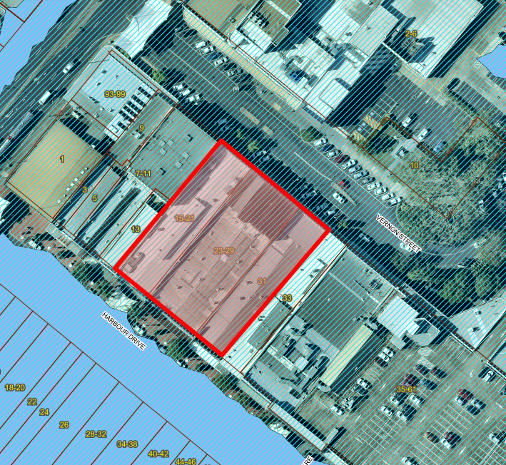

**Figure 1**: The subject site and the 1% AEP Flooded Extents. The hatched area indicates the Flood Planning Level and the 1% AEP Flooded Extents are indicated by the solid light blue area

The flood assessment of the site and the proposal reveals the following:

* The subject site is located within the Flood Planning Area, but is not inundated by the 1% AEP design event;
* The 1% AEP flood level for the adjacent Harbour Drive ranges from 4.3 – 4.8m AHD;
* Flood Planning Level (FPL) ranges from 4.8m AHD (4.3m AHD +0.5m) – 5.3m AHD (4.8m AHD + 0.5m) for the 1% AEP design event;
* The FPL adjacent to Retail 5 is 5.3m AHD; Retail 6 is 5.1m AHD; and Retail 7 is 4.8m AHD;
* The Lobby, and Retail 2 – 5 have a finished floor level of RL5.3m AHD;
* The finished floor levels for Retail 6 is 5.1m AHD; and Retail 7 is 4.8m AHD;
* Hazard is low with the subject site hazard zone H1 (generally safe for people, vehicles and buildings), and Harbour Drive hazard zone H2 (unsafe for small vehicles) for the 1% AEP design event;
* Depth of water and velocity of water in the adjacent Harbour Drive is very low for the 1% AEP design event;
* Commercial development is located at street level (RL4.7m AHD);
* Residential Development commences at Level 1 (> RL9.8m AHD);
* No fill is proposed for the site; and
* No subterranean carparking is proposed.

Given the above and due to the mixed nature of the proposed development, the proposal is considered compatible with the areas low flood hazard.

The site is currently developed and the redevelopment of the site will not significantly adversely affect flood behaviour. This is because the site is not located within the 1% AEP flooded extents. The velocity of floodwaters is a low flood hazard. The low velocity of water would not result in detrimental increases in the potential flood affectation of other development or properties within the immediate vicinity of the subject site. Furthermore, the proposal has incorporated appropriated finished floor levels that are above the 1% AEP flood level measures to manage risk to life from flood.

Given that the site is developed and within the commercial core precinct, the proposal is not likely to significantly adversely affect the environment or cause avoidable erosion, siltation, destruction of riparian vegetation or a reduction in the stability of river banks or watercourses. An erosion and sedimentation plan has been submitted with the application and conditions have been imposed to ensure that this development will minimise sedimentation of waterways.

Given the above it is not expected that the proposal will result in unsustainable social and economic costs to the community as a consequence of flooding.

**REVISED CONDITIONS**

After consultation with the applicant the following conditions have been revised. The applicant has reviewed the draft conditions and there are no other conditions of contention.

**Road Design and Services (Building)**:

14. The following works:

(a) Stormwater connections within Council reserve into Council infrastructure;

(b) Sewer Main Decommissioning and Upgrade;

(c) Water Main Upgrades;

(d) Entry Works;

(e) Half Road Construction and rectification on any Council assets along the Vernon Street frontage;

(f) Frontage works along Harbour Drive.

shall be provided to serve the development with the works conforming with the standards and requirements set out in Council’s Development Design and Construction specifications and relevant policies (Water Sensitive Urban Design).

Note:

1. The sewer main under the building is required to be decommissioned.
2. The sewer for the development must connect to the sewer main in Vernon Street, with the sewer main along the frontage to BA/06 being upgraded to a 225mm sewer main.
3. Water main upgrade to DN150 along the property frontage extending to the existing DN150 crossing of Grafton Street, unless other arrangements acceptable to Council are made.
4. The entry works shall include:
   1. blisters with street trees to be installed on either side of the entrance;
   2. Manouvring diagrams for the largest vehicle to enter the size shall be provided to ensure the blisters to not inhibit entry or exit from the development;
   3. The trees in the blisters are to be Michelia champaca;
   4. The driveway crossover is to have a continuous concrete footpath to indicate that pedestrians have right of way and Vernon Street maintains a continuous path of travel at one consistent level.
5. The (footpath) frontage in front of the development along Harbour Drive is to be rehabilitated in accordance with the Coffs Harbour City Centre Master Plan to Councils satisfaction.

Plans and specifications are to be submitted to Council and/or accredited private certifier and a separate **Civil Works Certificate** issued **prior to the issue of a Construction Certificate for the building works,** with the exception of the Ø150mm water main and the sewer main upgrade to service the development, where a separate **Civil Works Certificate** may be issued prior to the **issue of an Occupation Certificate**. Plan submissions are to be accompanied by payment of prescribed fee.

Plans and specifications submitted later than six (6) months from the date of development consent shall comply with Council’s current specifications at a date six (6) months prior to submission.

All work is to be at the developer’s cost.

**Road Design and Services:**

49. The following works:

(a) Stormwater connections within Council reserve into Council infrastructure;

(b) Sewer Main Decommissioning and Upgrade;

(c) Water Main Upgrades;

(d) Entry Works;

(e) Half Road Construction and rectification on any Council assets along the Vernon Street frontage;

(f) Frontage works along Harbour Drive.

Being provided to serve the development with the works conforming with the standards and requirements set out in Council’s Development Design and Construction specifications and relevant policies (WSUD).

These works must be completed prior to the issue of an Occupation Certificate.

All work is to be at the developer’s cost.